# 

Risk management by Parts in the Reinsurance Industry

TUSARKANTA KAR

Research Proposal

1

August 2021

# Abstract

An insurance company becomes responsible for handling risk/risks on behalf of its clients i.e., the insured, in exchange for a periodic sum of money called premium. A premium is the sum paid by the insured to the insurer in compliance with an insurance contract. If risk portfolio is extremely high compared to the capital of the company, it can transfer the risk (and premium) over to other companies, its reinsurers. Remainder of the risk that stays with the insurance company, that has signed an insurance contract with the insured, is called retention. Of course, the risks of the reinsurers can be transferred further to the next level of reinsurers. As a result, the initial risk is covered by a complete net of insurance and reinsurance from many insurance firms, each with its own retention. The challenge of actuarial mathematics is determining the size of retention and pay based on several aspects.

The current research proposed here will be focused on investigation of the mathematical structure of retention (and compensation) function which intrinsically depends on capital, earning, propensity to take risks by an insurance farm, and risk nonalignment. We discuss the monotonicity and support of retention functions to show that a certain type of functions qualifies as retention function under the assumption of linearization. Especially, the first order truncated Taylor series of a number of nonlinear functions can qualify as retention functions and Linear programming (LP) can be used to quickly determine the efficient portfolio formation for a reinsurer. Most importantly, we contradict the common perception in modelling reinsurance that the reinsurer should take the risk himself. Instead, in many practical cases, using the mathematical retention and compensation function, that division of risks at the level of reinsurance firms can be useful for risk reduction. Especially, given the constituent risks of PF2 type (Polya frequency function of order 2), the overall risk involved in the reinsurance contract is also PF2 type, and less than (or equal to) the sum of individual risks involved. Consequently, the reinsurer efficiency increases. We provide analysis for two use cases to show how machine learning strategies can help the business analytics of reinsurance farms using the proposed model.

**Table of Contents**

Abstract 1

1. Introduction 3

2. Background and related research 3

3. Research Questions (If any) 3

4. Aim and Objectives 3

5. Research Methodology 4

6. Expected Outcomes 4

7. Requirements / resources 4

8. Research Plan 4

References 4

# 1. Introduction

Reinsurance is a mechanism used by insurance companies to transfer a portion of their risk to another insurer, known as the reinsurer. It is a contractual arrangement where the reinsurer agrees to indemnify the insurer for losses incurred on the policies it has underwritten. The primary purpose of reinsurance is to help insurance companies manage their exposure to risks and protect their financial stability. By transferring a portion of their risks to a reinsurer, insurance companies can reduce their potential losses in the event of large and catastrophic claims. Reinsurance allows insurers to spread the risk across multiple parties, thereby mitigating the impact of individual losses.

Reinsurers provide coverage to insurers through various reinsurance structures, including proportional and non-proportional treaties, facultative reinsurance, and excess of loss agreements. In proportional reinsurance, the reinsurer shares a proportional portion of the premiums and losses with the insurer. In non-proportional reinsurance, the reinsurer covers losses that exceed a specific threshold. Facultative reinsurance involves individually underwriting specific risks. Excess of loss reinsurance provides coverage for losses that exceed a predetermined limit. Reinsurance plays a vital role in the insurance industry by providing insurers with financial stability, capacity to underwrite larger risks, and protection against catastrophic events. It also helps insurers meet regulatory requirements, maintain solvency, and enhance their ability to offer coverage to policyholders [1,2]. Reinsurers, in turn, earn premiums from providing coverage and manage their own risks through diversification and underwriting expertise. Overall, reinsurance serves as a crucial tool for insurers to manage their risks and ensure the long-term sustainability of the insurance industry.

Risk management in reinsurance refers to the process of identifying, assessing, and managing risks associated with reinsuring insurance policies. Reinsurance is a mechanism used by insurance companies to transfer a portion of their risk to another insurer, known as the reinsurer. The main objectives of risk management in reinsurance are to protect the reinsurer from excessive exposure to losses and to ensure the stability and profitability of the reinsurance business. This involves various activities [1, 3-5] including:

Risk Identification: Identifying and analyzing potential risks that can impact the reinsurer's financial stability, such as catastrophic events, economic downturns, or changes in regulatory requirements. Catastrophic events, such as natural disasters, can lead to significant losses for insurance companies and reinsurers. Identifying and assessing catastrophe risks involves analyzing historical data [6], using catastrophe model [7], and considering factors such as geographic exposure, vulnerability, and frequency of events [4,8].

Insurance companies and reinsurers typically invest premiums received from policyholders to generate income and meet future obligations. Identifying and managing investment risks involves assessing market volatility, credit risk, liquidity risk, and interest rate fluctuations. Reinsurance involves credit risk, which refers to the potential for the reinsurer to default on its obligations. Identifying and assessing credit risk involves evaluating the financial strength and creditworthiness of reinsurers before entering into reinsurance agreements. Compliance with regulatory requirements and changes in legal frameworks can also pose risks to insurance companies and reinsurers. Identifying and monitoring regulatory and legal risks helps ensure compliance and mitigate potential penalties or legal disputes. Further, operational risks arise from internal processes, systems, and human error. Identifying and managing operational risks involves assessing areas such as claims processing, data management, cybersecurity, and business continuity planning. Reinsurance companies face reputational risks from negative publicity, customer dissatisfaction, or unethical behaviour. Identifying and mitigating reputational risks involves monitoring industry trends, managing customer relationships, and maintaining high ethical standards.

Risk identification in reinsurance often involves a combination of quantitative and qualitative analysis. It requires collecting and analyzing data, conducting risk assessments, and considering various scenarios and potential impacts. By identifying and understanding these risks, insurance companies and reinsurers can develop appropriate risk management strategies to protect their financial stability and ensure their ability to meet policyholder obligations. The following factors have been described in [8,9] as main influencing factors.

**Risk Assessment:** Evaluating the likelihood and potential impact of identified risks to determine their significance and prioritize them accordingly. Insurance companies and reinsurers employ rigorous underwriting processes and risk assessment techniques to evaluate and select policies and risks. Thorough analysis of potential risks helps to identify and avoid high-risk or adverse selection situations, thereby reducing the overall risk exposure. Reinsurers often use sophisticated catastrophe modelling and risk analysis tools to assess the potential impact of catastrophic events, such as natural disasters. These models help in pricing reinsurance contracts appropriately and setting appropriate risk retention levels.

**Risk Mitigation:** Implementing strategies and measures to reduce or control the identified risks. This can involve diversifying the reinsurer's portfolio, setting appropriate underwriting guidelines, or establishing risk limits. It involves transferring a portion of the risk to a reinsurer, which helps protect the financial stability of the insurance company and ensures that it can fulfill its obligations to policyholders. By purchasing reinsurance, an insurance company transfers a portion of its risk exposure to a reinsurer. This helps to diversify and spread the risk across multiple entities, reducing the potential financial impact of large losses. Reinsurance allows for risk sharing between the insurance company and the reinsurer. The insurance company retains a portion of the risk, known as the "retention," while transferring the remaining risk to the reinsurer. This sharing of risk helps to limit the exposure of the insurance company and provides a financial buffer in the event of significant claims. Insurance companies and reinsurers carefully manage their portfolios to ensure a balanced distribution of risk. They consider factors such as geographic location, policy types, coverage limits, and industry sectors to diversify their exposure. This diversification helps to mitigate the impact of localized or sector-specific losses.

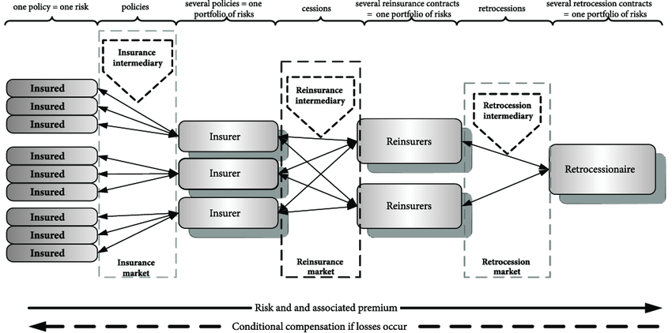

**Figure 1: Risk Management in insurance and Reinsurance: a schematic**

**Risk Transfer:** Transferring a portion of the risks (see Fig. 1) to other reinsurers or capital markets through various reinsurance structures, such as proportional or non-proportional treaties, facultative reinsurance, or catastrophe bonds. Reinsurance contracts include specific provisions and clauses that outline the terms and conditions of risk transfer, including limits, deductibles, and coverage restrictions. These provisions help to define the scope of risk assumed by the reinsurer and provide clarity in the event of a claim.

**Monitoring and Reporting:** Continuously monitoring the performance and exposure to risks, and regularly reporting to stakeholders, including regulators, rating agencies, and reinsured companies.

Effective risk management in reinsurance is crucial for reinsurers to maintain financial stability, meet regulatory requirements, and fulfill their obligations to reinsured companies. It helps them protect against unexpected losses, optimize their capital allocation, and ensure their long-term sustainability in the market. There are several models of risk reduction in reinsurance that insurers can utilize to manage their exposure to risks. Some common models include:

**Proportional Reinsurance:** In this model, the reinsurer and insurer share the premiums and losses in a proportionate manner. This can be done on a quota share basis, where the reinsurer takes a fixed percentage of each policy, or on a surplus share basis, where the reinsurer takes a percentage of the surplus on each policy. Proportional reinsurance helps insurers reduce their risk exposure by spreading it across multiple parties.

**Non-Proportional Reinsurance:** Non-proportional reinsurance involves the reinsurer covering losses that exceed a specific threshold, such as an aggregate deductible or a per-occurrence limit. This model provides coverage for catastrophic events or large losses. Non-proportional reinsurance can be structured as excess of loss or stop-loss agreements.

**Catastrophe Reinsurance:** Catastrophe reinsurance specifically focuses on protecting insurers against losses resulting from large-scale catastrophic events, such as earthquakes, hurricanes, or floods. Catastrophe reinsurance provides coverage for losses that exceed a predetermined threshold, often referred to as a "per-event" or "per-occurrence" limit.

**Facultative Reinsurance**: Facultative reinsurance involves individually underwriting specific risks on a case-by-case basis. Insurers can choose to cede a portion of the risk to the reinsurer based on their underwriting criteria. Facultative reinsurance allows insurers to manage their exposure to high-risk or unique policies.

**Retrocession:** Retrocession is a form of reinsurance where reinsurers transfer a portion of their risk to another reinsurer. This is typically done when the original reinsurer wants to reduce its own exposure or diversify its risk portfolio. Retrocession can be structured in various ways, including proportional and non-proportional arrangements.

**Alternative Risk Transfer (ART) Solutions:** ART solutions involve innovative reinsurance structures that go beyond traditional models. These can include insurance-linked securities (ILS), such as catastrophe bonds or insurance-linked notes, which transfer risks to capital market investors. ART solutions provide additional capacity and diversification options for insurers.

It's important to note that insurers often use a combination of these models to create a comprehensive and diversified reinsurance program that suits their specific risk management needs. The choice of models depends on factors such as the insurer's risk appetite, the type of risks being insured, and the market conditions.

While models of risk reduction in reinsurance offer valuable tools for insurers to manage their exposure to risks, they also have some shortcomings that should be considered. Some of the shortcomings include:

**1. Basis Risk:** Basis risk refers to the potential mismatch between the insurer's underlying risks and the risks covered by the reinsurance contract. There may be differences in policy terms, coverage limits, or triggers that can result in gaps in coverage. Insurers need to carefully assess and manage basis risk to ensure effective risk reduction.

**2. Counterparty Risk:** Reinsurance involves entering into contractual agreements with reinsurers. Insurers are exposed to counterparty risk, which is the risk that the reinsurer may not fulfill its obligations in the event of a claim. Insurers should conduct due diligence on the financial strength and reputation of the reinsurer to mitigate counterparty risk.

**3. Pricing and Affordability:** Reinsurance premiums are determined based on the level of risk transferred. However, pricing can be complex, and obtaining affordable reinsurance coverage may be challenging, especially for high-risk or niche markets. Insurers need to strike a balance between risk reduction and cost-effectiveness.

**4. Capacity Limitations:** Reinsurers have their own risk appetite and capacity limits. Insurers may face challenges in finding suitable reinsurers willing to take on their risks, especially for large or complex risks. This can limit the availability of reinsurance coverage and potentially leave insurers exposed to significant losses.

**5. Regulatory and Legal Considerations:** Different jurisdictions may have varying regulatory requirements and legal frameworks for reinsurance. Insurers need to ensure compliance with these regulations and consider any legal implications of their reinsurance arrangements.

**6. Over-reliance on Reinsurance:** While reinsurance provides risk reduction, over-reliance on reinsurance can create a false sense of security. Insurers should not solely rely on reinsurance as their primary risk management tool. It is important for insurers to maintain appropriate underwriting practices, risk diversification, and sound financial management.

To mitigate these shortcomings, insurers should carefully assess their risk management strategies, conduct thorough due diligence on reinsurers, diversify their reinsurance program, and regularly monitor and review their reinsurance arrangements [15,16] to ensure they align with their risk management objectives.

# 2. Background and related research

While mathematics plays a crucial role in risk reduction in reinsurance, there are some shortcomings and challenges associated with its application. Some of the shortcomings in the mathematics of risk reduction in reinsurance include:

The accuracy and reliability of risk models heavily depend on the quality and quantity of data available. In some cases, historical data may be limited, especially for emerging or rare risks. Insufficient or incomplete data can lead to inaccuracies in risk assessment and modeling, potentially impacting the effectiveness of risk reduction strategies. Risk models often rely on assumptions and simplifications to make calculations more manageable. However, these assumptions may not always accurately reflect the complexities and uncertainties of real-world risks. Oversimplification can lead to inaccurate risk projections and inadequate risk reduction measures.

Risk models are based on statistical analysis and probability theory, which inherently involve uncertainties. The future occurrence of catastrophic events or other unforeseen circumstances may deviate significantly from historical patterns, making it challenging to accurately quantify and manage risks. Risk models often assume independence of risks, but in reality, risks can be correlated or dependent on each other. Ignoring or underestimating the interdependencies between risks can lead to inaccuracies in risk assessment and the effectiveness of risk reduction strategies.

Moreover, the selection and calibration of risk models involve inherent limitations and potential biases. Different models can produce different results, and the choice of a particular model may introduce model risk. It is essential for insurers to understand and validate the models used in risk reduction to ensure their reliability and appropriateness. Note that Mathematics and risk models are tools that rely on human interpretation and decision-making. Human biases, errors, or misinterpretations can impact the effectiveness of risk reduction strategies. It is crucial to have skilled and experienced professionals who can appropriately apply mathematical models and interpret their results.

To mitigate these shortcomings, insurers should regularly review and update their risk models, incorporate exact quantitative analysis with sensitivity metric to assess the impact of uncertainties, and continuously improve data quality and availability. It is important to recognize that mathematics is a valuable tool, but it should be used in conjunction with physical considerations regarding risk management theory to ensure comprehensive and effective risk reduction in reinsurance. Especially, the physical properties of a risk model in reinsurance should clearly outline the mathematical properties of retention and compensation which is defined below from established risk management practice in reinsurance. Note the minimization of risk of ten involves extremizing these functions (or some invariants of them).

**Definition 0: (Risks and Claims)** *Risk* is the combination of the probability of an event and its consequence. In general, this can be explained as: Risk = Likelihood × Impact. In other words,

The actual amount of *claim* is determined by the formula: Claim = Loss Suffered × Insured Value/Total Cost. The object of such an average clause is to limit the liability of the insurance farm. In terms of life insurance, claim amount can be defined as the sum payable at the maturity of an insurance policy or upon death of the person insured to the beneficiary or the nominee or the legal heir of the insured.

**Definition 1: (Retention)** In the context of reinsurance, the term "retention function" refers to a mathematical function that determines the level of risk or exposure that an insurance company chooses to retain for itself before transferring the remaining risk to a reinsurer. When an insurance company writes policies, it assumes the financial responsibility for any potential claims that may arise from those policies. However, to mitigate its risk and protect its financial stability, the insurance company may choose to transfer a portion of the risk to a reinsurer. The retention function helps determine how much risk the insurance company is willing to retain before seeking reinsurance coverage. The retention function typically takes into account various factors, such as the type of insurance coverage, the financial strength of the insurance company, its risk appetite, and regulatory requirements. It is often expressed as a mathematical formula or a table that maps different levels of exposure or policy limits to corresponding retention amounts.

For example, a retention function for property insurance may state that the insurance company will retain 10% of the risk for policies with a coverage limit of up to $1 million, 20% for policies with a coverage limit between $1 million and $5 million, and so on. This means that for policies falling within these coverage limits, the insurance company will retain the specified percentage of the risk, and the remaining portion will be transferred to the reinsurer. The retention function plays a crucial role in determining the risk-sharing arrangement between the insurance company and the reinsurer. It helps the insurance company strike a balance between retaining an acceptable level of risk and transferring the excess risk to the reinsurer, thus ensuring its financial stability and ability to meet potential claims obligations.

Retention, as a function of claim variable *x,* is expressed as [**17]**

,

where the term on the left of the equality is the amount of retention, *R(x), E(x)* are the amount of risk and profitability (or earning) and *AL(x) i*s the nonalignment of risk for the claim variable, and *C* is the capital invested.

**Definition 2: (Compensation)** In the context of reinsurance, a "compensation function" typically refers to a mathematical function that determines the amount of compensation or reimbursement that a reinsurer provides to an insurance company for the portion of risk transferred.

When an insurance company purchases reinsurance, it transfers a portion of its risk exposure to a reinsurer in exchange for a premium. In the event of a covered loss, the insurance company may seek compensation from the reinsurer to help cover the costs associated with the claims. The compensation function in reinsurance calculates the amount of reimbursement that the reinsurer will provide to the insurance company based on predefined terms and conditions outlined in the reinsurance contract. This function considers factors such as the loss amount, the retention level of the insurance company, and the specific reinsurance agreement.

The compensation function may take various forms depending on the type of reinsurance arrangement. For example, in proportional reinsurance, the function may involve a simple percentage calculation, where the reinsurer reimburses a fixed percentage of the covered loss incurred by the insurance company. In non-proportional reinsurance, the function may be more complex and involve a combination of thresholds, deductibles, and limits to determine the compensation. The purpose of the compensation function in reinsurance is to ensure that the insurance company is adequately reimbursed for the portion of risk transferred to the reinsurer, helping to maintain its financial stability and ability to meet claims obligations. The specific details of the compensation function are typically outlined in the reinsurance contract, which establishes the terms and conditions governing the reimbursement process.

Consider the function *x - RET(x) = K(x)* from the definition of retention. *K(x) i*s called the compensation function. Note that for a given *RET(x),* the utility function *u(x)*, the reinsurer efficiency can be calculated as: [**17,18-20,36]**



Here *P* is the premium to be paid and is the claim variable. At the entire portfolio level, the reinsurer efficiency is shown in the Function . The reinsurer is often in the position to choose whether he will cover only a part of the offered risk and give over the remaining part to other.

reinsurers or take on the risk himself. If the individual risks associated with each claim is additive, then the total risk is calculated as 

As X is a random variable we want to know the distribution type that governs the risks so as to confirm that the global structure of risk is additive with respect to the local structures. This also confirms that the local structure of retention and compensation for each claim variable X carries over to the overall retention and compensation functions. The answer is PF2 density functions with guaranteed positive definiteness which confirm the monotonicity of retention and compensation. This comprises first part of the thesis results before the linear programming for risk reduction.

**Definition 3: (Positive Definiteness)** A positive definite function is a mathematical concept that is commonly used in the field of linear algebra and optimization. It is a function that satisfies certain properties related to positive definiteness, which is a key property in various mathematical and statistical applications. Formally, a real-valued function *f(x)* defined on a vector space is said to be positive definite if, for any non-zero vector *x*, the following condition holds [14,15]:

***f(x)* > 0**

Additionally, a positive definite function must satisfy the following properties:

The function is symmetric, meaning that *f(x) = f(y)* for any vectors *x* and *y*. The function *f(x)* = 0 only when *x* = 0, i.e., it is positive definite and not positive semi-definite. Positive definite functions are often used as objective functions or as part of constraints in optimization problems. They help ensure that the optimization process converges to a minimum or maximum point. Positive definite functions are closely related to positive definite matrices. A function f(x) is positive definite if and only if the matrix formed by the second derivatives of*f(x)* is positive definite. Positive definite functions play a crucial role in multivariate analysis and covariance structure modelling. For example, the covariance matrix of a multivariate distribution must be positive definite, ensuring that the distribution is well-defined.

Overall, positive definite functions are fundamental in many areas of mathematics and provide valuable mathematical properties that help in solving optimization problems, analysing data, and studying various mathematical structures.

**Definition 4: (Monotonic Function)** A monotonic function is a mathematical function that preserves or maintains the order of its inputs. In other words, it is a function that either always increases or always decreases as its input values increase. Formally, a function *f(x)* defined on a certain interval is said to be:

1. Monotone increasing if, for any two values a and b in the interval, with *a < b*, it holds that *f(a)* ≤ *f(b)*. This means that as the input values increase, the function values also increase or stay the same.

2. Monotone decreasing if, for any two values a and b in the interval, with *a < b*, it holds that *f(a)* ≥ *f(b)*. This means that as the input values increase, the function values either decrease or stay the same.

A function can be strictly monotone if the inequality in the definition is strict (i.e., *f(a) < f(b)* for increasing monotone or *f(a) > f(b)* for decreasing monotone).

Monotonic functions have several important properties and applications:

Monotonic functions preserve the order of their inputs. This property is useful in various mathematical and statistical analyses where maintaining the order of data is important.

Monotonic functions have well-defined inverses. If a function is strictly increasing or strictly decreasing, its inverse function will also be monotonic.

Monotonicity can be used to optimize functions. For example, if a function is monotone increasing, finding the minimum value is equivalent to finding the input value where the function equals its minimum value.

Monotonic functions are often used in decision-making models or utility theory. These functions represent preferences that are consistent with increasing or decreasing satisfaction or desirability. Examples of monotonic functions include linear functions, exponential functions, power functions, and logarithmic functions.

**Definition 5: (PF2 Function)** The PF2 (Polya frequency) function (see Fig. 2 for example) is a mathematical function used in the field of combinatorial problems to count the number of ways to colour objects with certain restrictions. It is named after the Hungarian mathematician George Pólya, who made significant contributions to the study of counting and enumeration. The PF2 function is defined as follows:

*PF2(n, k) = (1/k) * ∑ [d | n] μ(d) * k^(n/d)*

where:

- *n* is the number of objects to be coloured

*- k* is the number of available colours

*- d* divides *n*

*- μ(d) is the Möbius function*, which takes the value 1 if *d* has an even number of prime factors, -1 if d has an odd number of prime factors, and 0 if *d* is divisible by a square number greater than 1. For a detailed introduction into the theory of PF2 functions see e.g. Karlin (1968). The PF2 function exhibits symmetry, meaning that *PF2(n, k) = PF2(n, n-k)*. This property arises from the fact that colouring objects with k colours is equivalent to colouring them with n-k colours. These functions arise in the context of probability theory because many common distributions possess Lebesgue, or counting densities which are PF2. Therefore we consider in the sequel PF2 functions which are integrable to 1.

The PF2 function has applications in various areas, including graph theory, group theory, and combinatorial enumeration. It provides a powerful tool for counting the number of colorings with certain constraints and has been extensively studied in the field of combinatorics. A more formal definition follows from: [26-28]

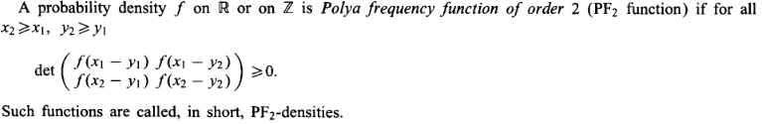

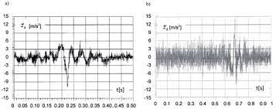

Figure 2: Example of PFn functions [21]

**Definition 6: (Linear Programming Problem)** Linear programs are problems that can be expressed in [standard form](https://en.wikipedia.org/wiki/Canonical_form" \o "Canonical form) as [33-37]:



Linear Programming Problems (LPP) [10-12] are problems that are focused with determining the best value for a given linear function. The ideal value might be either the greatest or the least. The supplied linear function is regarded as an objective function in this context. Linear programming is a technique for optimizing a linear objective function under linear equality and linear inequality constraints. Its viable region is a convex polytope, which is a set defined as the intersection of an infinite number of half spaces, each specified by a linear inequality. Its goal function is a polyhedral real-valued affine (linear) function. A linear programming algorithm locates a place on the polytopes where this function has the least (or greatest) value (if such a point exists.).

The aim of actuarial mathematics is to apply mathematical and statistical techniques to assess and manage risk in various financial and insurance contexts. Actuarial mathematics involves analyzing data, modelling risk, and making predictions to help individuals and organizations make informed decisions regarding risk management and financial planning. Actuarial mathematics helps assess and quantify various types of risks, such as mortality risk, morbidity risk, longevity risk, and financial risk. By analyzing historical data and using statistical models, actuaries can estimate the likelihood and impact of different risks.

Actuaries play a crucial role in setting insurance premiums and determining appropriate reserves. They use mathematical models to assess the expected claims and expenses associated with insurance policies, ensuring that premiums adequately cover the potential losses and expenses. Actuaries assist in identifying and managing risks by developing risk mitigation strategies, such as reinsurance programs, hedging techniques, and capital management strategies. They use mathematical models, such as stochastic modeling and scenario analysis, to evaluate the impact of different risk management strategies. Actuaries ensure compliance with regulatory requirements by performing financial and risk assessments that meet regulatory standards. They provide expertise in areas such as solvency requirements, reserve adequacy, and risk-based capital assessments. Overall, the aim of actuarial mathematics is to help individuals, businesses, and insurance companies make informed decisions in the face of uncertainty, by applying mathematical and statistical techniques to understand and manage risk effectively. In the context of risk management, the terms "retention function" and "compensation function" refer to two different approaches in handling risk.

The research until now has been focusing around predicting fixed linear model with respect to a big reinsurance farm. However, models heavily rely on historical data to estimate probabilities, correlations, and other parameters. Insufficient or low-quality data can introduce biases and inaccuracies in the model outputs. Additionally, models may struggle to account for emerging or unforeseen risks due to the lack of relevant historical data. Additionally, reinsurance and risk management involve dealing with uncertainties and volatile market conditions. Models may struggle to accurately capture and quantify these uncertainties, leading to potential inaccuracies in risk assessments and decision-making. Mathematical models typically assume rational and consistent behaviour from market participants. However, human behaviour can be influenced by emotions, biases, and other psychological factors, which may not be fully accounted for in the models. This can lead to discrepancies between model predictions and actual outcomes.

As reinsurance and risk management become more sophisticated, the underlying models can become complex, involving numerous assumptions, parameters, and calculations. This complexity introduces the risk of model errors, model degeneracy, and model misuse, which can undermine the reliability of model outputs. Mathematical models used in reinsurance and risk management must comply with regulatory requirements and legal frameworks. However, these regulations and laws can evolve over time, and models may struggle to adapt to changing requirements and constraints. It is crucial to recognize these limitations and exercise caution when relying solely on mathematical models for reinsurance and risk management. Note that models should be used as tools to inform decision-making, but they should not be treated as easy feed for machine learning alone. Expert judgment, qualitative analysis, and a holistic understanding of the business context should complement the insights provided by exact mathematical models.

We emphasize that depending on the structure of the retention and compensation function, efficiency of reinsurance policies increases if the claims are divided among multiple farms. We examine the structure of local retention and compensation functions so that the global structure is approximately retained through superposition. In this context we examine densities of the PF2 type (Poly’s frequency function of order 2) to model the overall risk involved in the reinsurance contract and the consequent reinsurer’s efficiency. The assumption that the retention functions and compensation functions are monotonously increasing is Valid as incremental claims suppose not only the share increase of an insurance company, but also of its reinsurers in covering the claim amount. We show that this aspect forces additional structure on the retention functions and compensation functions that helps us determine the reinsurer’s efficiency and the type of distributions that allows compensation functions to be treated as a stochastic objective function.

# 3. Research Questions (If any)

Mathematical structures of compensation and retention functions play a crucial role in setting reinsurance models and determining appropriate returns. Overall, the aim of actuarial mathematics is to help individuals, businesses, and insurance companies make informed decisions in the face of uncertainty, by applying mathematical and statistical techniques to understand and manage risk effectively. In the context of risk management, the terms "retention function" and "compensation function" refer to two different approaches in handling risks. The thesis shows that the risks better be divided into small parts for a risk insurance farm to increase reinsurer efficiency under the practical condition of monotonicity of retention and compensation. Especially, given the constituent risks of PF2 type (Poly’a frequency function of order 2), the overall risk involved in the reinsurance contract is also PF2 type, and less than (or equal to) the sum of individual risks involved. Consequently, the reinsurer efficiency increases. We use the property of monotonicity, and positive definiteness to bring out the locally linear structure of certain retention and compensation functions. The structure of overall retention and compensation functions follow the respective local structures so that a locally linear risk reduction (and, return maximization) problem can be formulated for constructing portfolios in the reinsurance market.

The thesis, also, proposes an LPP for constructing efficient portfolios from reinsurance efficiency function as obtained from data in reinsurance markets. The Pareto solutions aim to determine the balanced equilibrium between expected retention and the compensation below a specific threshold. Stochastic parameters in the risk and retention is handled using the structure of retention functions that can be suitably linearized. The proposed scheme emphasizes the algorithmic methods available in LPP to numerically calculate the structure of efficient portfolios for given reinsurance contracts by parts. The Pareto solutions arise from the superposition individual LPP solutions. Risk-LPP can be solved numerically by realizing the two-step method available for algorithmically solving group constraints, The Pareto solution fronts, defined by the convex-type equality ~x∗(α) = α~x∗1 + (1 − α)~x where α ∈ [0, 1] are central to risk reduction and compensation augmentation. Choosing a numerical value of α, the specific structures are derived and plotted for the desired reinsurance portfolio. Note that when α = 1, the effective portfolio of reinsurance company, that corresponds to the maximum expected value of return, is characterized, and in the case where α = 0, the structure of the effective reinsurance portfolio, that corresponds to the minimum risk, is realized. We provide a multi-objective algorithm for Pareto solutions in retention and compensation in reinsurance which can introduce the deep learning methods to decision-making in reinsurance.

# 4. Aim and Objectives

The retention function involves retaining or assuming a certain portion of the risk within an organization or individual's own resources. Instead of transferring the risk to an external party, such as an insurer or reinsurer, the entity retains the financial responsibility for potential losses. The retention function is commonly used when the cost of transferring the risk is deemed higher than the potential loss itself. It requires the entity to have sufficient financial resources to cover potential losses. The compensation function, on the other hand, focuses on transferring the risk to an external party, typically through insurance or reinsurance contracts. By paying premiums or fees, the entity shifts the financial responsibility for potential losses to the insurer or reinsurer. The compensation function provides protection against unexpected losses and helps mitigate the financial impact of those losses. It's important to note that the specific mathematical structures of compensation and retention functions in reinsurance can vary significantly based on the terms and conditions outlined in the reinsurance contract. The models of these functions outlined in the thesis provide a general understanding of the mathematical representations commonly applicable in reinsurance, but actuarial details may differ based on the specific agreement between the insurer and reinsurer. Especially, the behaviour of the PF2 function can be quite complex and depends on the specific values and relationships for a large insurance farm. Therefore, it is necessary to analyse the PF2 function for determining reinsurer efficiency on a case-by-case basis to understand its monotonicity properties accurately.

Both retention and compensation functions have their advantages and considerations. Retaining risk allows for more control over the risk management process and may be cost-effective for smaller or less severe risks. However, it also exposes the entity to the full financial consequences of potential losses. On the other hand, transferring risk through compensation provides financial protection and can help mitigate the impact of large or catastrophic losses. However, it involves costs in the form of insurance premiums or reinsurance fees. The decision to use either the retention function or compensation function depends on various factors, including the entity's risk appetite, financial strength, the nature of the risk, and the cost-benefit analysis of retaining versus transferring the risk. Risk management professionals and actuaries often analyse these factors to determine the most appropriate risk management strategy for a given situation.

Insurers can use linear programming to optimize their risk retention levels. By formulating the problem as a linear programming model, insurers can set constraints on the amount of risk they retain for different types of policies or coverage areas. The model can consider factors such as the insurer's capital position, risk tolerance, and the potential cost of reinsurance. The objective is to find the optimal balance between retaining risk and transferring it through reinsurance to minimize overall risk exposure. Linear programming can assist insurers in selecting the most appropriate reinsurance contracts or reinsurers. By formulating the problem as a linear programming model, insurers can set constraints and objectives based on factors such as pricing, coverage limits, financial stability of reinsurers, and contractual terms. The model can help determine the optimal combination of reinsurance contracts that minimizes the potential for losses while maximizing the benefits of risk transfer. Overall, linear programming provides a mathematical framework to optimize risk reduction strategies in reinsurance. By formulating the problem as a linear programming model, insurers can make data-driven decisions to allocate risk, select reinsurance contracts, and optimize capital allocation to minimize potential losses and enhance their financial stability. Intelligent estimation of retention function and compensation function is difficult from organizational and personal data of insurance details without imposing certain mathematical structures on the objective. Both of retention function and compensation function can be risk minimization objectives depending on the context; but we show that one forces certain structures on the other. Further, these mathematical structures ensure that retention function and compensation functions can be nonlinear while the risk can be reduced locally, especially if the risks do not associate global calamities and catastrophe where local linearization may turn out to be invalid due to the limitation on tangent spaces. The proposed framework can be used to estimate company specific retention and compensation policies over a period of claim repayment. However, the retention function often depends on a few other conditions like pandemic, man-made disasters which we do not include. However, the retention function often depends on a few other conditions like pandemic, man-made disasters which we do not include. However, the retention function often depends on a number of other conditions like pandemic, man-made disasters which we do not include.

# 5. Research Methodology

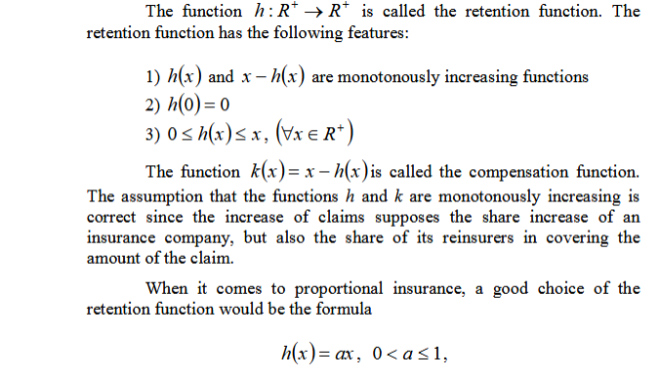 (5.1)

This is the structure of local retention and compensation functions. As *X (claim x) i*s a random variable we want to know the distribution type that governs the risks so as to confirm that the global structure of risk is additive with respect to the local structures. This also confirms that the local structure of retention and compensation for each claim variable X carries over to the overall retention and compensation functions. The answer is PF2 density functions with guaranteed positive-definiteness which confirm the monotonicity of retention and compensation. We exploit the following results from real analysis and probability theory to show that if each of the claims in random variable *X* is PF2 then the total risk is also PF2.

**Proposition 1: [21]**

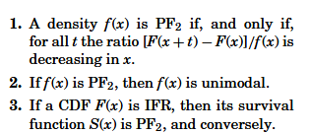

The following theorem is due to **B. Efron [22], and others later [21-23].**

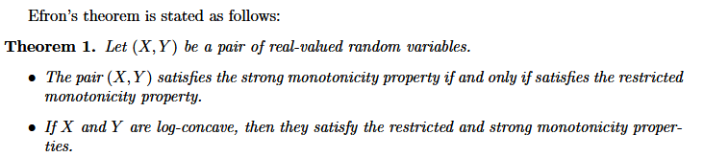

We impose the log-concavity assumption on the compensation functions from theorem 1. The following result from statistics and probability theory handles the conditional expectation for modelling risks [].

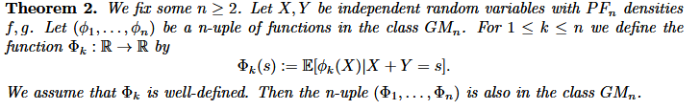(5.2)

The following theorem can be found in advanced texts on linear algebra **[27].**

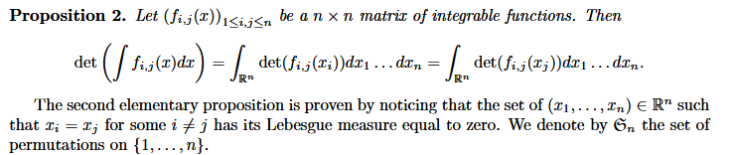

Now we come to the first main result for risk characterization in reinsurance. The result is given for *Xi,* *i=2*, but by method of induction, can be extended to finite number of risks. We provide an outline of the proof that PF2 risk densities are additive.

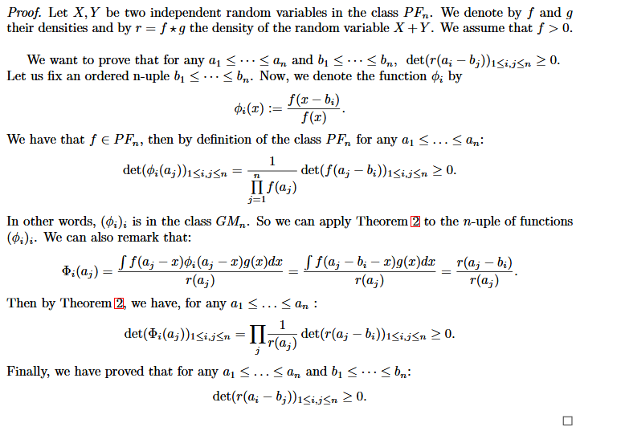

Using a more elaborate version of Efron’s theorem, with a stronger assumption on the monotonicity of φ on each claim variable we can derive a more powerful conclusions. We state the two different

Mathematical forms. The forms differ in their choice of the continuous random variable or a integer valued mass function.

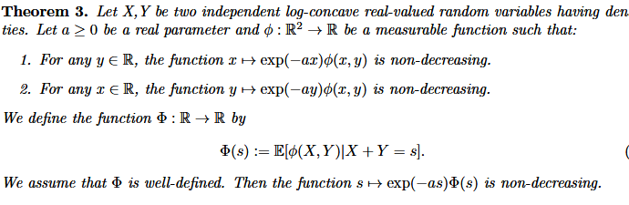

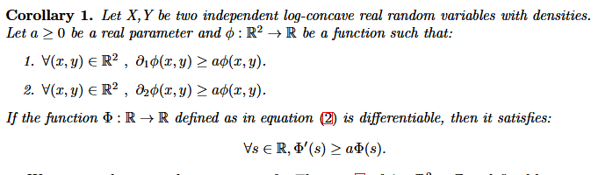

The following theorem is due to **B. Efron [23],** which allows us to fix the type of distributions that can model the risks associated with the network of insurance and reinsurance described in **Fig. 1.** The allowed probability distributions are listed after we the statement of the theorem. The proof for individual distributions can be found in advanced text of measure theory **[24-26].**

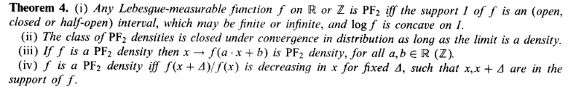

**Allowed probability distributions:**

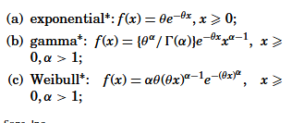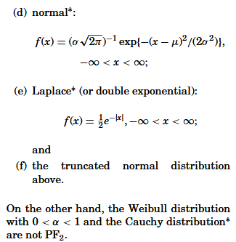

These are the allowable distributions among the prominent ones to model the individual risks associated with individual claims *Xi*  to redistribute risk in such a way that the total risk is still PF2.

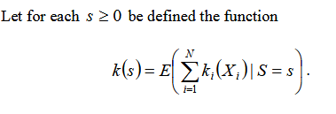.………………………… (5.3)

Then *k(s)* is a valid compensation function and

from

 is a valid reinsurer efficiency function. This we prove in the main and final theorem.

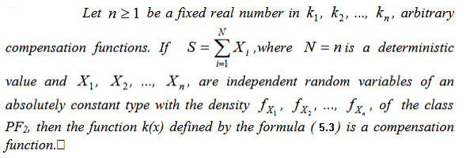

This confirms that the PF2 risks are locally additive, and the right side of equation (5.3) represents a compensation function and *X - k(x)* is a global retention function that can be used for risk reduction and increase in reinsurer’s efficiency.

Because the primary goal of an insurance company's effective portfolio formation is to redistribute risk in order to reduce its aggregate value while maintaining an acceptable level of profitability, forming an effective portfolio composition is one of the primary tasks of analytical management in insurance companies. This study considers the challenge of efficient portfolio creation in the reinsurance market. Linear programming can be applied to various aspects of risk management. One common application is in portfolio optimization, where the goal is to construct an investment portfolio that maximizes returns while minimizing risk. The linear programming problem in risk management [28-31] can be formulated as follows:

Objective: Maximize the expected return of the portfolio

Constraints:

1. The total investment amount should not exceed the available budget.

2. The portfolio should meet certain risk constraints, such as a maximum allowable volatility or a target value-at-risk.

3. The weights assigned to each asset in the portfolio should sum up to 1 (indicating a fully invested portfolio).

By formulating these constraints and objectives, linear programming techniques can be used to solve for the optimal allocation of investments that balances risk and return. The resulting solution provides the weights of each asset in the portfolio, allowing risk managers to make informed decisions and

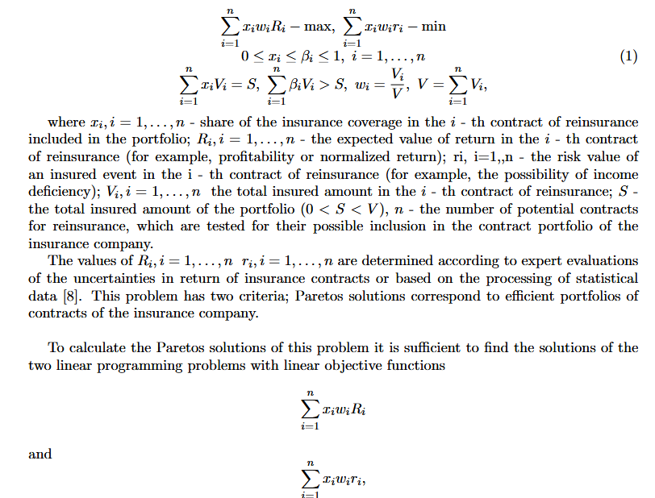manage risk effectively. It's important to note that the specific formulation and constraints of the linear programming problem may vary depending on the specific risk management objectives and constraints of the organization.

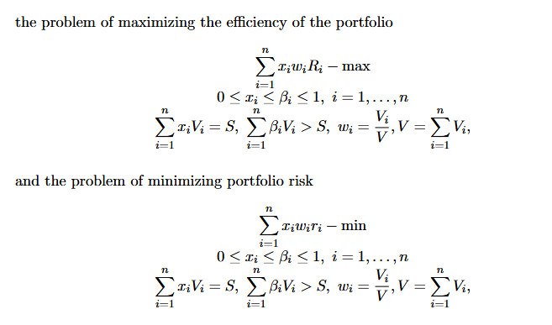

# 6. Expected Outcomes

The solution methodology for arbitrary dimensions are suggested below that can be used in MLOps [32]based representation for machine learning of reinsurer efficiency. MATLAB based simulations are also useful in visualizing certain trends prescribed in the model.

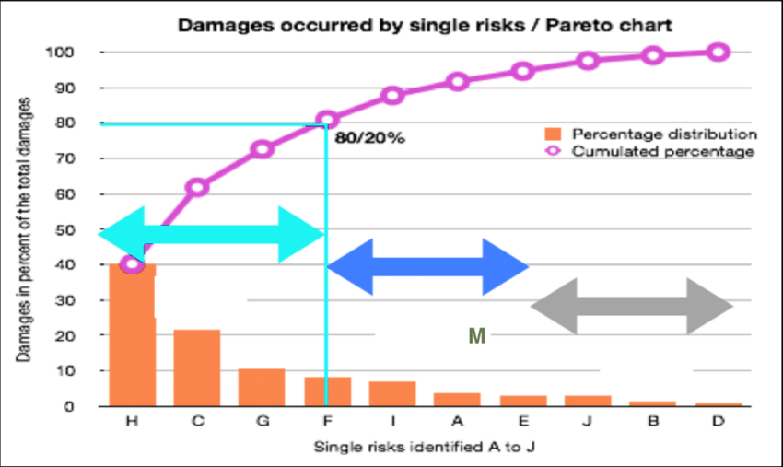

**Figure 3: Risk Management in Reinsurance: a Pareto chart for linearized problems**

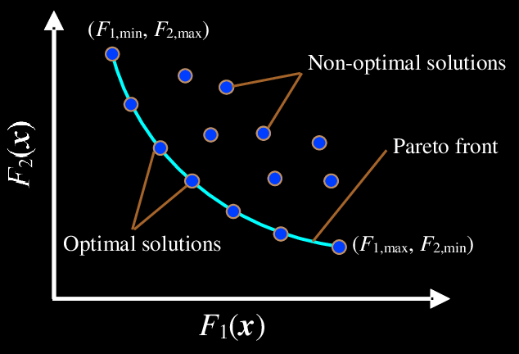

**Figure 4: Example of Pareto front solutions resembling rectangular hyperbola.**

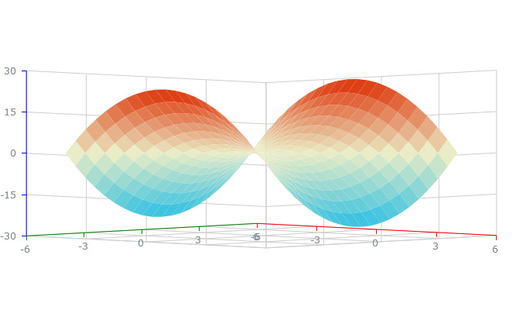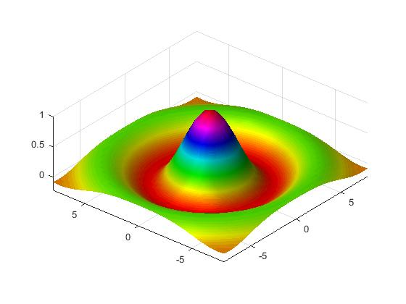

**Figure 5: Various Retention and compensation profiles for bivariate claims**

A risk matrix is a popular tool used for risk classification and prioritization. It categorizes risks based on their likelihood (probability) and impact (severity) to determine their overall risk level. The risk matrix typically consists of a grid with different levels of likelihood and impact, and each intersection represents a specific risk classification. Here is a common classification scheme for a risk matrix:

**1. High Risk (Red Zone):** Risks falling in this zone have both a high likelihood and a high impact. These risks are considered critical and require immediate attention and mitigation strategies.

**2. Medium Risk (Yellow Zone):** Risks in this zone have either a moderate likelihood and high impact, or high likelihood and moderate impact. These risks are significant and should be closely monitored and managed to prevent them from escalating.

**3. Low Risk (Green Zone):** Risks in this zone have either a low likelihood and high impact, or high likelihood and low impact. While these risks may not require immediate action, they should still be monitored and managed to prevent any potential negative consequences.

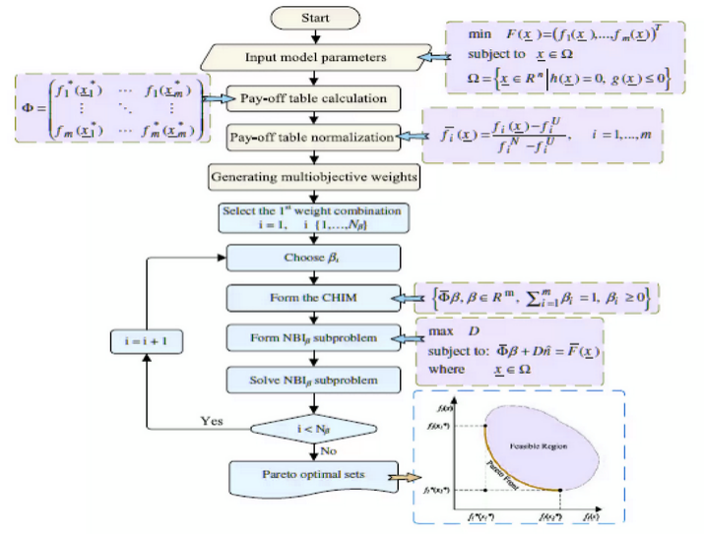

**Figure 6: Risk reduction by multi-objective optimization for Pareto solutions: a schematic.**

**4. Negligible Risk (Blue Zone):** Risks falling in this zone have both a low likelihood and low impact. These risks are considered minor and may not require significant attention or resources. However, they should still be periodically reviewed and assessed.

It is important to note that the specific classification scheme and color coding used in a risk matrix may vary depending on the organization or industry. The purpose of the risk matrix is to visually represent the relative levels of risk and aid in decision-making for risk management strategies.

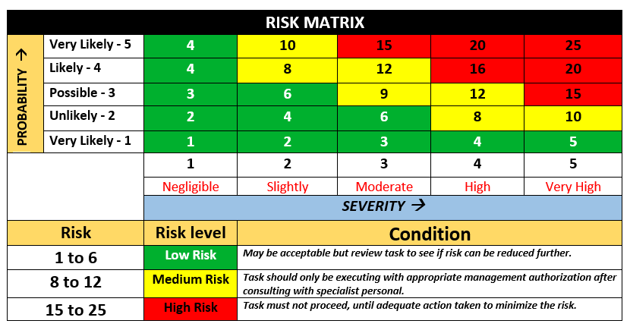

**Figure 7: Risk Management through risk matrix structure**

We use the result of the Pareto front to classify the risk regions for a given reinsurance contract with PF2 type claims.

# 7. Requirements / resources

**Required Resources**

16 GB RAM, 32 GB free space, Ports

1x USB 3.2 Gen 1, 1x USB 3.2 Gen 1 (Always On), 1x USB-C 3.2 Gen 1 (support data transfer, Power Delivery 3.0 and DisplayPort 1.4),1x USB-C 3.2 Gen 2 (support data transfer, Power Delivery 3.0 and DisplayPort 1.4), 1x HDMI 1.4b, 1x Ethernet (RJ-45), 1x Headphone / microphone combo jack (3.5mm)

**Processor**

AMD Ryzen™ 3 7330U Processor (2.30 GHz up to 4.30 GHz)

**Operating System**

Windows 10/LINUX

**Memory**

8 GB Soldered DDR4 3200MHz

**Hard Drive**

256 GB SSD M.2 2242 PCIe Gen4 TLC Opal

**Display Type**

40.64cms (16) WUXGA (1920 x 1200), IPS, Anti-Glare, Non-Touch, 45%NTSC, 300 nits

**Graphics**

Integrated Graphics

**Wireless**

Realtek RTL8852BE Wi-Fi 6 11AX (2x2) & Bluetooth® 5.1

Reinsurance Dataset, Python Libraries, ML Ops, MATLAB and Mathematica 11. TensorFlow, Py Tech. LaTeX for mathematical writing with MikTeX.

# 8. Research Plan



Since the main purpose of the effective portfolio formation of an insurance company is the redistribution of risk to reduce its aggregate value, while maintaining an acceptable level of profitability, the task of forming an effective composition of portfolios is one of the main tasks of analytical management in insurance companies. The problem of efficient portfolio formation in the reinsurance market, considered in this paper. Mathematical models are generated through derivations using linear algebra, statistics, and analysis.

# References

1. Lloyd's 360 Risk Project - Understanding Risk: A Review of Lloyd's Risk Management Tool.
2. Reinsurance Principles and Practice" by Brian Cochrane.
3. Principles of Risk Management and Insurance" by George E. Rejda.
4. Reinsurance Management: A Practical Guide" by David Atkinson.
5. Catastrophe Risk and Reinsurance: A Country Risk Management Perspective" by Céline G. L. Yeh.
6. Solvency II: Stakeholder Communications and Change" by Karel Van Hulle.
7. Alternative Risk Transfer: Integrated Risk Management Through Insurance, Reinsurance, and the Capital Markets" by Erik Banks.
8. Enterprise Risk Management: Today's Leading Research and Best Practices for Tomorrow's Executives" by John R. S. Fraser and Betty J. Simkins.
9. Reports from the Intergovernmental Panel on Climate Change (IPCC) and organizations like the Geneva Association.
10. Dantzig, G. B. (April 1982). ["Reminiscences about the origins of linear programming"](https://apps.dtic.mil/sti/pdfs/ADA112060.pdf) (PDF). *Operations Research Letters.* 1 (2): 43–48. [doi](https://en.wikipedia.org/wiki/Doi_(identifier)" \o "Doi (identifier)):[10.1016/0167-6377(82)90043-8](https://doi.org/10.1016/0167-6377(82)90043-8)

1. Sierksma, G. and Zwols, Y. (2015). *Linear and Integer Optimization: Theory and Practice*(3rd ed.). CRC Press. p. 1. [ISBN](https://en.wikipedia.org/wiki/ISBN_(identifier)" \o "ISBN (identifier)) [978-1498710169](https://en.wikipedia.org/wiki/Special:BookSources/978-1498710169" \o "Special:BookSources/978-1498710169).
2. Deb, K. *Optimization for Engineering Design*, EEE 2nd Edition (2003)
3. Dasgupta, B. *Applied Mathematical Methods*, Prentice-Hall 2nd Edition (2007)
4. Kreyzig, E. *Advanced Engineering Matheatics*, EEE 2nd Edition (2003)
5. Balashov R B and Kryanev A V 2016 Vestnik Natsionalnogo Issledovatelskogo Yadernogo Universiteta MIFI 5 174–6
6. Kryanev A V, Lukin G V and Udumyan D K 2010 Metric analysis and data processing (Moscow: FIZMATLIT)
7. Kryanev A V and Cherny A I 1996 Mathematical modeling 8 97–103
8. Pass C, Lowes B and Davies L 1998 COLLINS Dictionary of Economics (Saint Petersburg: Higher School of Economics)
9. Golubin A Y 2003 Mathematical models in the theory of insurance: construction and optimization (Moscow:Ankil)
10. Zhuravlev Y 1994 Dictionary of terms in insurance and reinsurance (Moscow: Ankil)
11. Kornilov I A 2004 Basics of Insurance Mathematics (Moscow: FIZMATLIT)
12. Tulinov V V and Gorin V S 2000 Insurance and risk management. Terminological dictionary (Moscow: Nauka)
13. Fedorova T A (ed) 2009 The essence of the form and legal basis of reinsurance. Insurance: a textbook (Moscow:Magistr)
14. Oudghiri Y Generalizations of Efron’s theorem [Statistics & Probability Letters](https://www.sciencedirect.com/journal/statistics-and-probability-letters" \o "Go to Statistics & Probability Letters on ScienceDirect) [Volume 177](https://www.sciencedirect.com/journal/statistics-and-probability-letters/vol/177/suppl/C" \o "Go to table of contents for this volume/issue), October 2021, 109158
15. Efron B. Increasing properties of Pólya frequency function, Ann. Math. Stat. (1965), pp. 272-279
16. Karlin S., Proschan F.Pólya type distributions of convolutions Ann. Math. Stat. (1960), pp. 721-736
17. Saumard A., Wellner J.A. Log-concavity and strong log-concavity: A review, Stat. Surv., 8 (2014), p. 45.
18. Saumard A., Wellner J.A. Efron’s monotonicity property for measures on R2 J. Multivariate Anal., 166 (2018), pp. 212-224.
19. Schoenberg I.J. On Pólya frequency functions, J. Anal. Math., 1 (1) (1951), pp. 331-374
20. Weinberger H.F., A characterization of the Pólya frequency functions of order 3, Appl. Anal., 15 (1–4) (1983), pp. 53-69

.

1. Yan-Kun, Y. et al., Pareto-optimal solution for multiple objective linear programming problems with fuzzy goals, [Fuzzy Optimization and Decision Making](https://link.springer.com/journal/10700) volume 14, pages 43–55 (2015)
2. <https://www.slideshare.net/AmoghMundhekar/multiobjective-optimization-and-trade-offs-using-pareto-optimality>
3. Daduna, H. et al. A queueing theoretical proof of increasing property of Polya frequency functions, [Statistics & Probability Letters](https://www.sciencedirect.com/journal/statistics-and-probability-letters" \o "Go to Statistics & Probability Letters on ScienceDirect) [Volume 26, Issue 3](https://www.sciencedirect.com/journal/statistics-and-probability-letters/vol/26/issue/3" \o "Go to table of contents for this volume/issue), 15 February 1996, Pages 233-242

1. https://en.wikipedia.org/wiki/Relationships_among_probability_distributions
2. KARLIN, S. et al, MOMENT INEQUALITIES OF P ´OLYA FREQUENCY FUNCTIONS, Vol. 11, No. 3 BadMonth 1961.
3. <https://www.researchgate.net/publication/272081654> Mathematical models of insurance and reinsurance.
4. Mathematical modelling of risk reduction in reinsurance R B Balashov, A V Kryanev, D E Sliva, National Research Nuclear University MEPhI, Kashirskoe highway 31, 115409, Moscow, Russia